Sound vibrations

When something vibrates it can make a sound.
A vibration is a shake or a wobble.
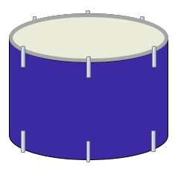
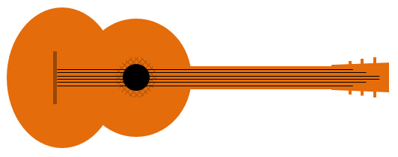



- What vibrates to make a sound?
For each statement, tick (✓) one column to show what you think.
Places |  | I am sure this is right | I think this is right | I think this is wrong | I am sure this is wrong
A | The guitar strings
B | The skin on the drum
C | The metal in the horn
D | The air in the horn

Physics > Big idea PSL: Sound, light and waves > Topic PSL1: Sound and light > Key concept PSL1.1: Production and transmission of sound
Diagnostic question
Sound vibrations

Overview
Learning focus: | Objects and materials can be made to vibrate to produce a sound that becomes louder as the size of vibration increases and higher pitched as the rate of vibration increases.
Observable learning outcome: | Identify what vibrates to make sound.
Question type: | Confidence grid
Key words: | Vibrate, vibration

P | PRIOR UNDERSTANDING  This diagnostic question probes understanding of ideas that are usually taught at age 5-11, to aid transition from earlier stages of learning.

What does the research say?
Young children and some students may attribute the production of sound to the physical attributes of an object (for example, the tautness of a drum) or to the force used to make the sound (such as a hand hitting a drum), before developing an understanding that sound is caused by vibrations (Driver et al., 1994).
In a study of two-hundred-and-sixty 4-16 year old students Asoko, Leach and Scott (1991) found that students use of ‘vibrations’ to explain the source of sound increased with age, but this was also dependent on the context: 80% of students aged 11-16 used vibrations to explain sound when the vibrations were obvious (for example in a string); when air was vibrating in a horn this fell to 40%; and very few students used vibrations to explain the sound caused by knocking two small stones together.
This question explores the contexts in which students recognise what vibrates to cause a sound.
Ways to use this question
Students should complete the confidence grid individually. This could be a pencil and paper exercise, or you could use an electronic ‘voting system’ or mini white boards and the PowerPoint presentation.
If there is a range of answers, you may choose to respond through structured class discussion. Ask one student to explain why they gave the answer they did; ask another student to explain why they agree with them; ask another to explain why they disagree, and so on. This sort of discussion gives students the opportunity to explore their thinking and for you to really understand their learning needs.

Differentiation
You may choose to read the question to the class, so that everyone can focus on the science. In some situations it may be more appropriate for a teaching assistant to read for one or two students.
Expected answers
All of the objects or materials vibrate to make sound.
How to respond - what next?
The objects and materials in this question are listed in order of how obvious students are likely to recognise that they vibrate to make a sound.
The metal in the horn vibrates to give the note its particular timbre, the air inside the horn is amplified because it resonates inside the horn.
If students have misunderstandings about the metal or air vibrating (because this is not obviously visible), then they could, for example, feel a metal instrument when it is being played. A vibrating tuning fork can be clearly heard when held next to an ear, and the vibrations felt when it is placed gently on an ear lobe. Dipped into water, a tuning fork splashes when it is vibrating.
A video clip (or a practical demonstration) of a Ruben’s tube can be used to show air vibrating.
Acknowledgments
Developed by Peter Fairhurst (UYSEG), with examples chosen from Asoko et al (1991).
Images: UYSEG
References
Asoko, H. M., Leach, J. and Scott, P. H. (1991). A study of students' understanding of sound 5-16 as an example of action research. Annual Conference of the British Educational Research Association. Roehampton Institute, London.
Driver, R., et al. (1994). Making Sense of Secondary Science: Research into Children's Ideas, London, UK: Routledge.

